**Workflow Manager**

This module allows students to raise request like bus change, bus discontinue, bus service, hostel service, fee discount, hostel room change, library fine waved off, meal, test and complain

This module consists of one sub module named as **Request Manager**

Request Manager’s front screen is shown in the figure where the list of request by particular student is displayed

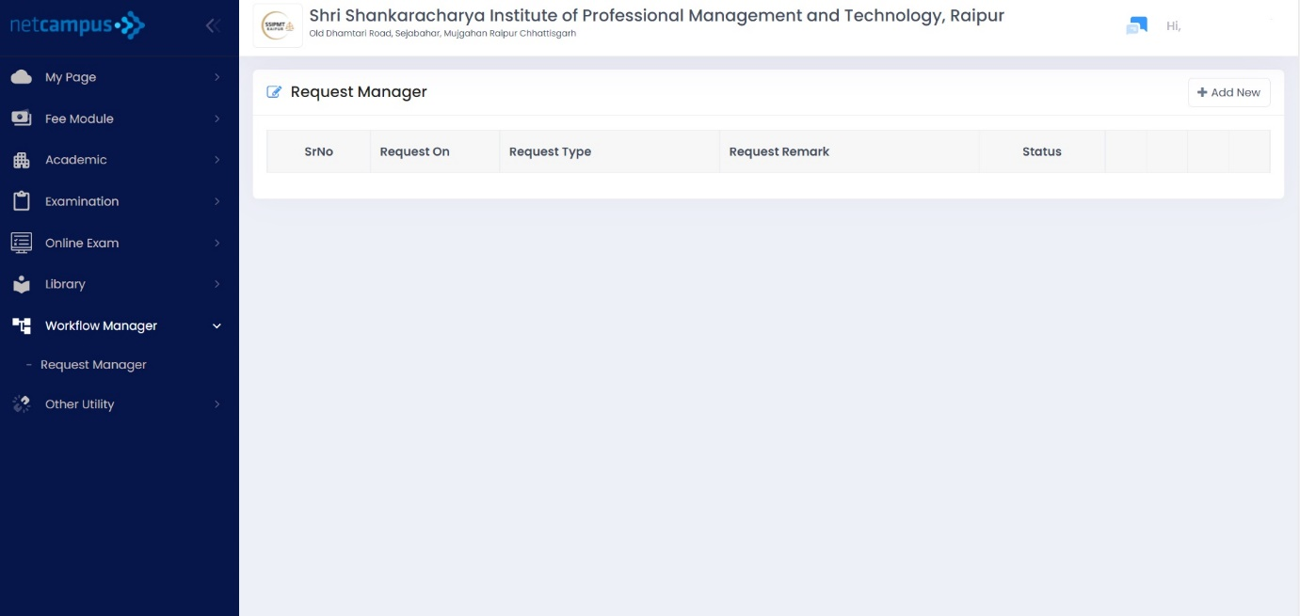

Student can request for any of the issues through this module by just clicking on add new option



After Clicking on add new option the screen appears as shown in the figure

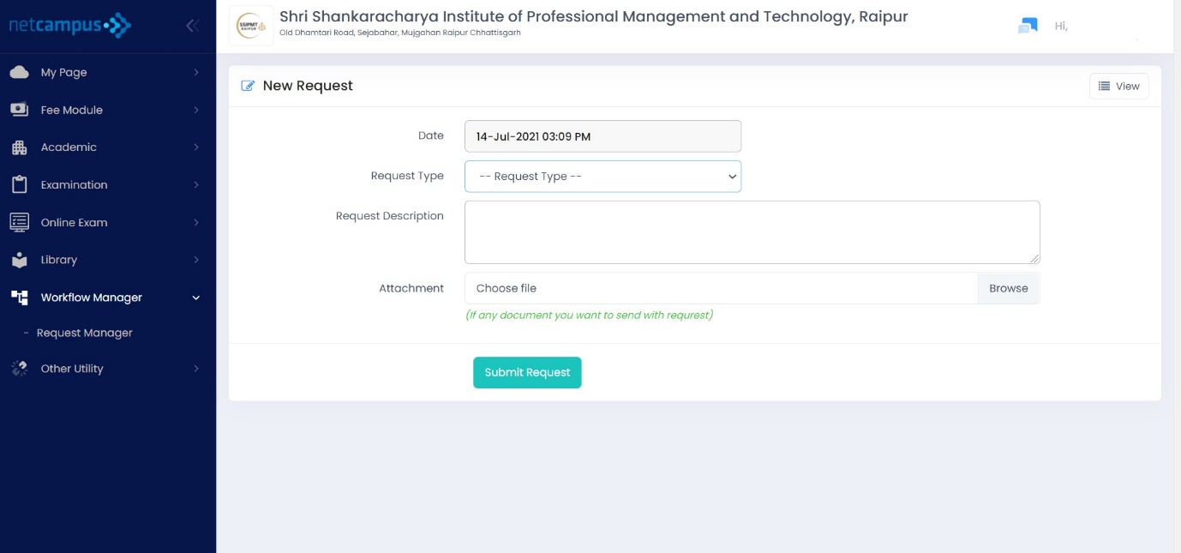

Step 1 Click on the Request type option the list will appear containing all the request as shown in the figure

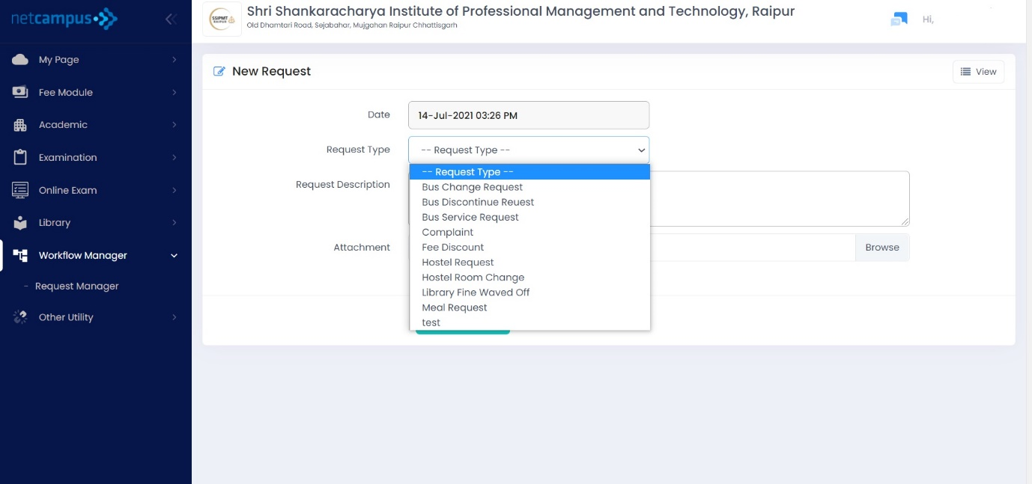

Step 2 Select any of the request which they want to raise and then add the details asked in each request

Step 3 Add the request description

Step 4 (optional) Add the attachment if any by clicking on browse option as shown in figure



Step 5 Click on the Submit Request to submit the request



To view the request, click on the view option as shown on the figure

